Store Manager User Guide

Team 8

**Table of Contents**

**Logging Into the System** **3**

**Product Catalogue (Store Department)** **3**

Browse Product Catalogue 3

Select the list of stationery 4

**Supplier List** **4**

View the Supplier List 4

Add new supplier 4

Edit Supplier Details 5

Delete Supplier 5

View the list of stationery supplied by a particular supplier 6

Edit the price of the stationery supplied 6

Delete a stationery supplied by a particular supplier 6

Add a new item supplied by a particular supplier 7

**Department Details** **7**

View Department details 7

**Store Manager Adjustment Voucher List** **7**

**Stationery Trend Analysis and Prediction** **9**

# Logging Into the System

The system will be accessed via the below page. User is to enter the provided credentials into the username and password boxes.

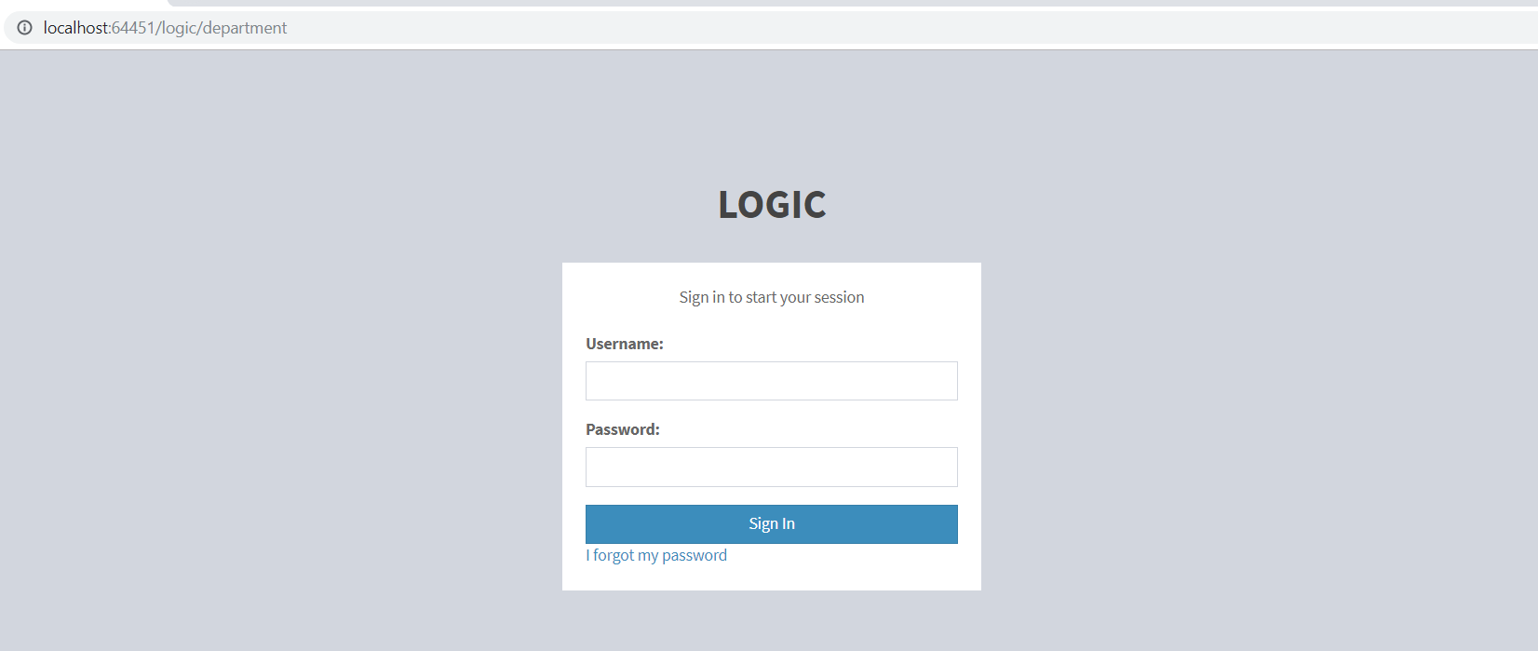

# Product Catalogue (Store Department)

## Browse Product Catalogue

On the side bar menu, click on the ‘Product Catalogue’. It will lead to the lists of the category of the stationery

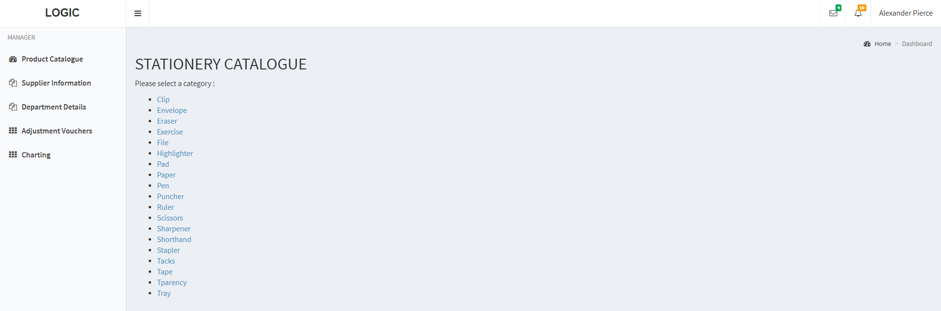

## 

## Select the list of stationery

To view the list of the stationery, user can click on one of the category and it will lead to the whole list of stationeries belong to that category.

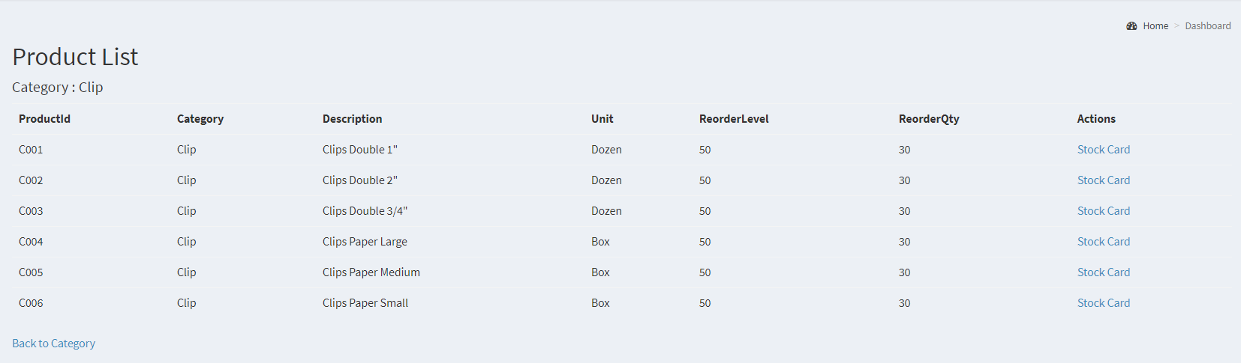

# Supplier List

## View the Supplier List

User will be able to view the supplier details where it stores the information of all suppliers

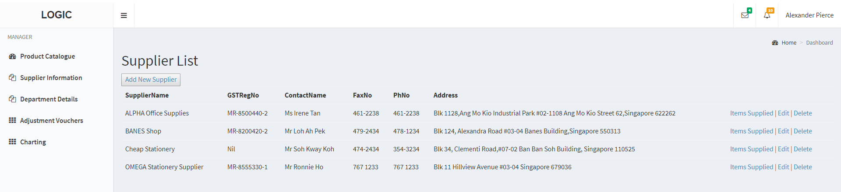

## 

## Add new supplier

In a situation where Logic University Purchasing Department engages with new supplier (with or without tender), once there is an agreement between both parties to do business, Logic University Purchasing Department will need to pass on the new supplier information to Logic University Store Manager. The store manager will then be able to create a new supplier details **.**

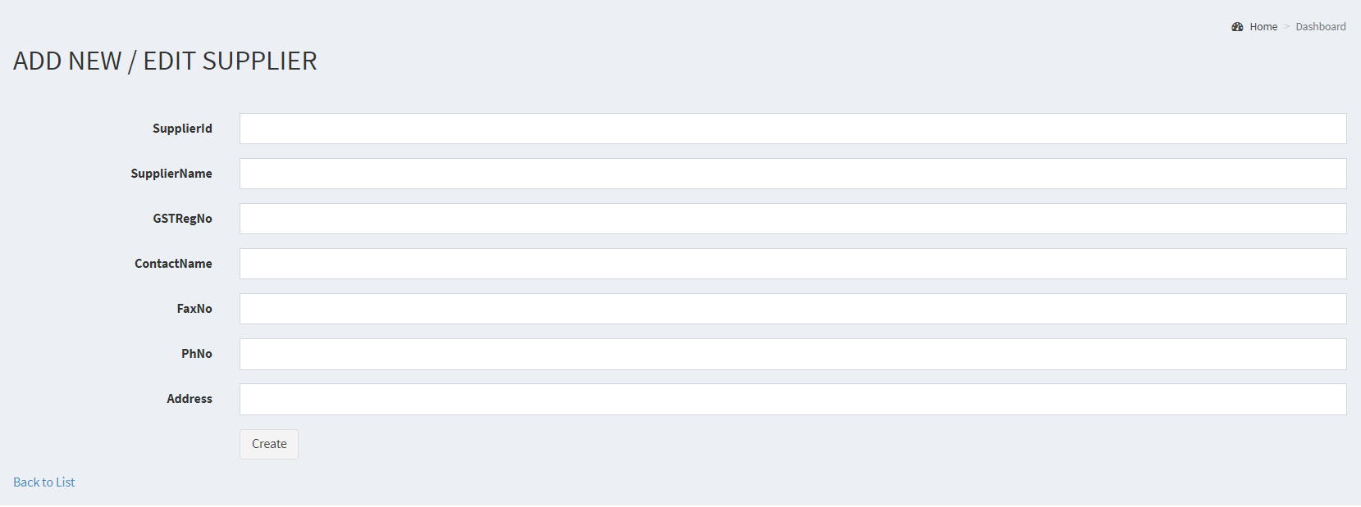

## Edit Supplier Details

On the right hand side of the supplier, user will be given view choices. User will be able to edit the supplier details when there are changes.

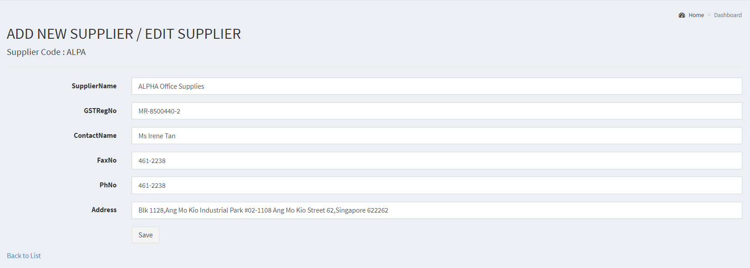

## Delete Supplier

User will also be able to remove supplier details when a particular supplier is no longer supplying stationery to Logic University.

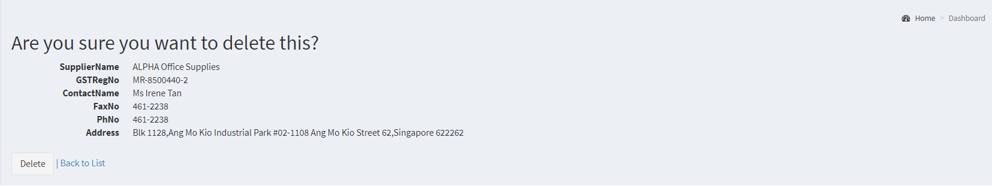

## View the list of stationery supplied by a particular supplier

Each supplier supplies different stationeries and user will be able to view the list of stationeries provided by this supplier. User will have to click on the ‘Items supplied’ by each of the supplier to view the stationery list.

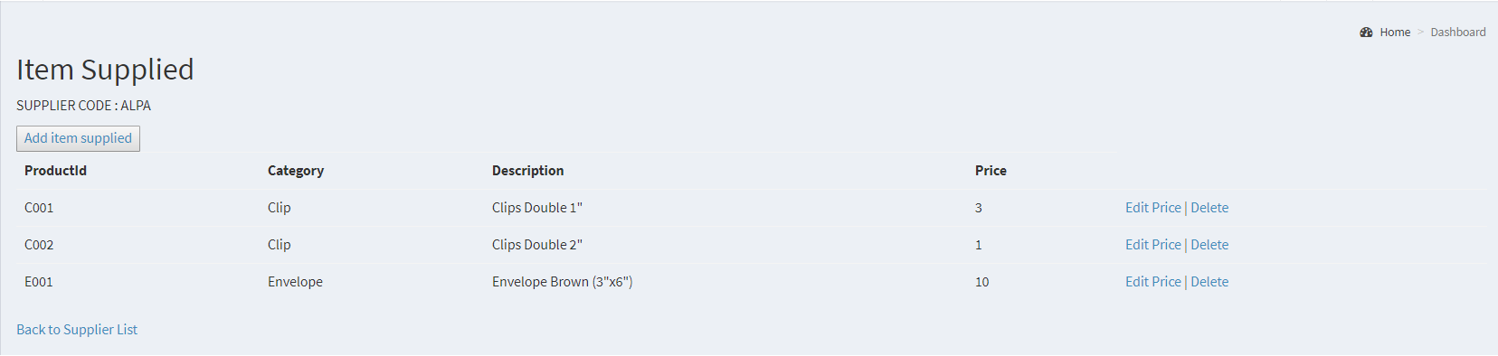

## Edit the price of the stationery supplied

Each year Logic University will have a tender for the purchase of stationery. Logic University Purchase Department will pass on the newest information, after the tender, to the Logic University Store Manager. Store Manager will receive the information and edit accordingly to the newest price.

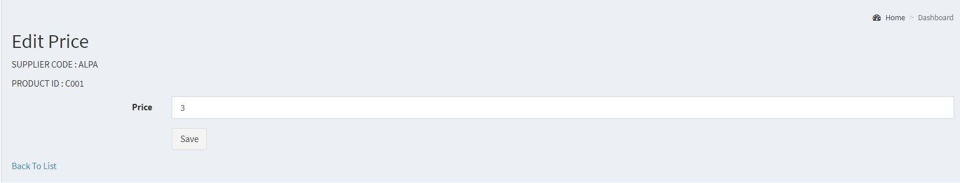

## Delete a stationery supplied by a particular supplier

In case a stationery is no longer supplied by this particular supplier, user will be able to delete it.

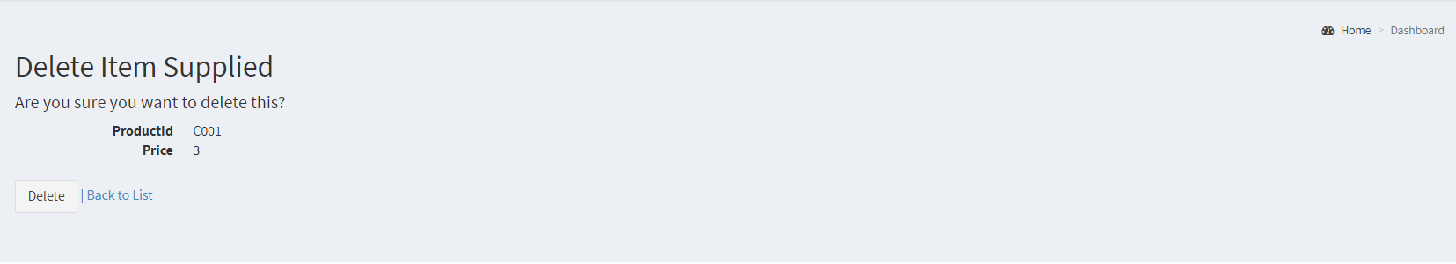

## Add a new item supplied by a particular supplier

For each new tender every year, there could be a situation where a particular supplier may supply a new stationery. Hence, the store manager will be able to create a new item supplied under that particular supplier.

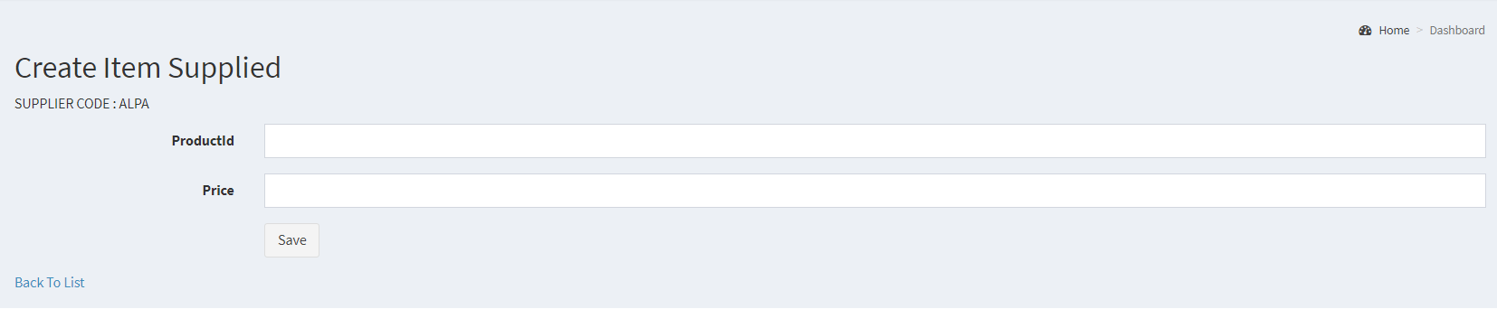

# Department Details

## View Department details

User will be able to view the department details of Logic University. User may also refer to the collection point of each department in case they need to refer, as well as the representative and head name of each department.

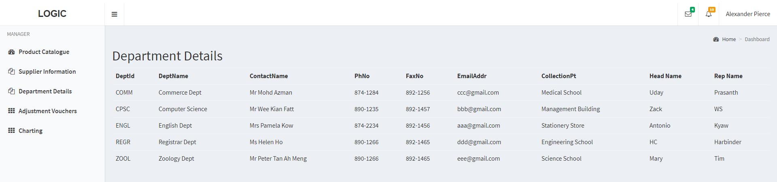

# Store Manager Adjustment Voucher List

Once the Adjustment Vouchers are submitted by the store clerk,if the total calculated price of the Adjustment Voucher is Greater than $500,then the request goes to Store Manager.

Once the Store Manager logs in he can see all the requests which has adjustment amount Greater than $500 with status as “Pending”.

The Store Manager can click on the pending request. Once the store manager clicks on the pending request it navigates to a page where the supervisor can approve or reject the request with comments.The store Manager can only view the Rejected or Approved requests but cannot modify.

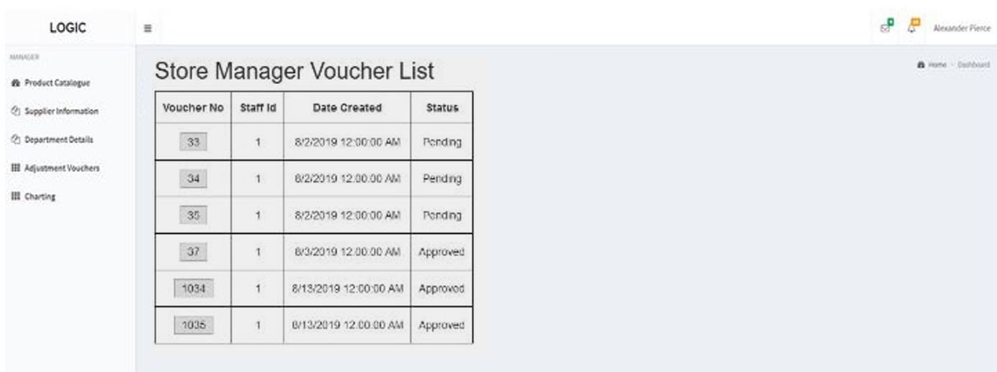

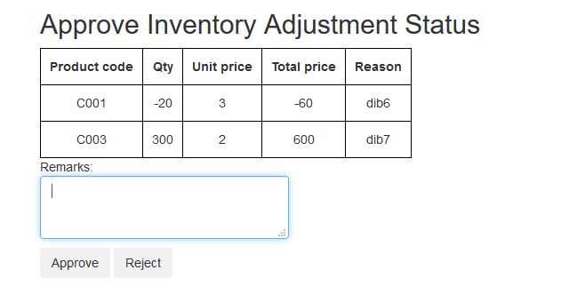

# 

# Stationery Trend Analysis and Prediction

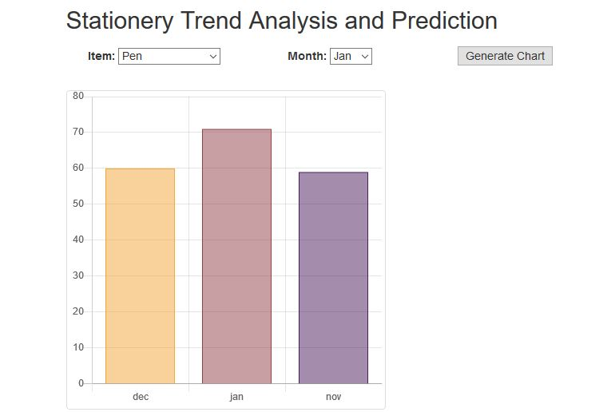

The page allows the store clerk to make predictive analysis by selecting the item category and the month. For example, if the user chooses the month, he can measure the quantity of items sold for the previous two months along with a predicted quantity for the month chosen. By checking the predicted quantity, the clerk can alter the reorder level of this particular item based on the demand. The “Generate chart” button is used to generate bar charts as per the predicted data using the previous years data as a basis for generating the model. The quantity can be viewed by hovering the mouse over the chart.